1. Login

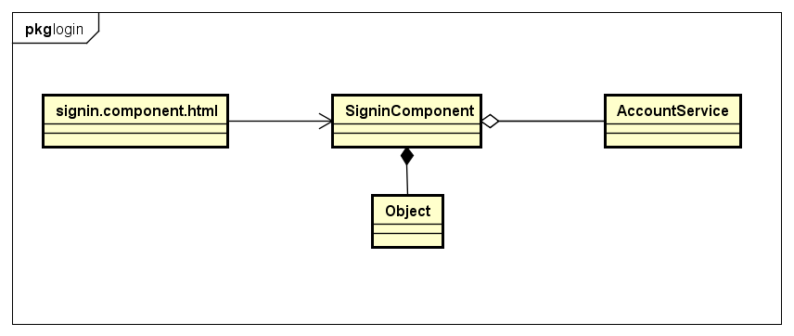

1. Singin.component.html

Reference to UI design

1. SigninComponent

|  |  |  |  |
| --- | --- | --- | --- |
| **Attribute** | | | |
| No. | Name | Type | Description |
| 1 | signinForm | FormGroup | Formgroup instance for signin form |
| 2 | submitAttemp | boolean | Check if user click submit button |
| 3 | signingin | boolean | Show handling signing in progress |
| 4 | invalidData | boolean | Show if data is invalid |

|  |  |  |  |  |
| --- | --- | --- | --- | --- |
| **Method** | | | | |
| No. | Name | Params | Return type | Description |
| 1 | signIn | signinData: any,  isValid: boolean | boolean | Sign user in |

1. AccountService

|  |  |  |  |
| --- | --- | --- | --- |
| **Attribute** | | | |
| No. | Name | Type | Description |

|  |  |  |  |  |
| --- | --- | --- | --- | --- |
| **Method** | | | | |
| No. | Name | Params | Return type | Description |
| 1 | signIn | data: any | Observable | Send request to sign user in |

1. Object (Javascript Object)
2. Logout

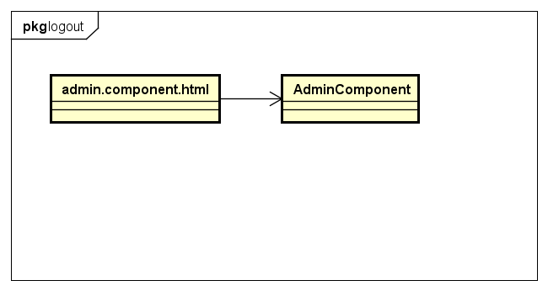

1. Admin.component.html

Reference to UI design

1. AdminComponent

|  |  |  |  |
| --- | --- | --- | --- |
| **Attribute** | | | |
| No. | Name | Type | Description |

|  |  |  |  |  |
| --- | --- | --- | --- | --- |
| **Method** | | | | |
| No. | Name | Params | Return type | Description |
| 1 | signOut |  | void | Sign user out |

1. Manage medical category

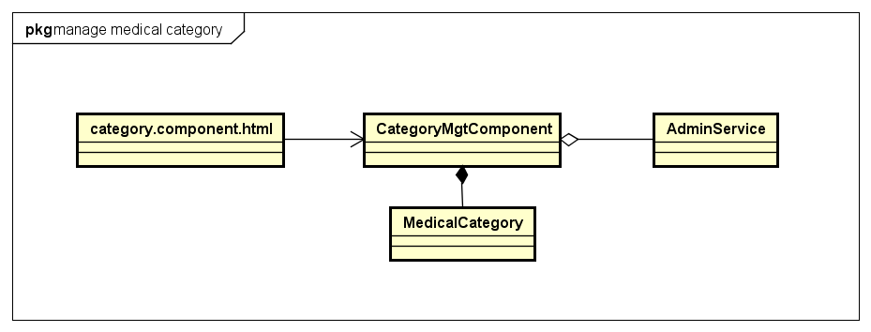

1. category.component.html

Reference to UI design

1. CategoryMgtComponent

|  |  |  |  |
| --- | --- | --- | --- |
| **Attribute** | | | |
| No. | Name | Type | Description |
| 1 | currentPage | number | Keep current page is been viewing |
| 2 | totalPages | number | Store total number of pages |
| 3 | totalRecords | number | Store total number of medical categories |
| 4 | caregories | MedicalCategory[] | Store list of current categories |
| 5 | showLoader | boolean | Indicate loading data |
| 6 | newCateForm | FormGroup | FormGroup instance for create medical category |
| 7 | editCateForm | FormGroup | FormGroup instance for edit medical category |
| 8 | submitAddAttempt | boolean | True if user click submit button in create form, false otherwise |
| 9 | submitEditAttempt | boolean | True if user click submit button in edit form, false otherwise |
| 10 | addingCate | boolean | Indicate handling creating medical category |
| 11 | editingCate | boolean | Indicate handling editing medical category |
| 12 | existsCate | boolean | Indicate if a medical category already exists |

|  |  |  |  |  |
| --- | --- | --- | --- | --- |
| **Method** | | | | |
| No. | Name | Params | Return type | Description |
| 1 | createCategory | data: any, isValid: boolean | void | Handle create new medical category |
| 2 | editCategory | data: any, isValid: boolean | void | Handle edit current medical category |
| 3 | openAddNewCategory |  | void | Open add medical category modal |
| 4 | openEditCategory | cate: MedicalCategory | void | Open edit medical category modal |
| 5 | closeAddCategoryModel |  | void | Close add medical category modal |
| 6 | closeEditCategoryModel |  | void | Close edit medical category modal |
| 7 | trackByID | index: number,  item: MedicalCategory | string | Track medical list by its ID |

1. AdminService

|  |  |  |  |
| --- | --- | --- | --- |
| **Attribute** | | | |
| No. | Name | Type | Description |

|  |  |  |  |  |
| --- | --- | --- | --- | --- |
| **Method** | | | | |
| No. | Name | Params | Return type | Description |
| 1 | createMedrecordCategory | account: Account,  data: MedicalCategory | Observable | Send request create medical category |
| 2 | updateMedrecordCategory | account: Account,  data: MedicalCategory | Observable | Send request update a medical record |
| 3 | filterMedrecordCategories | account: Account, name: string, pageNo: number, records: number | Observable | Send filter filter medical cateogries with conditions |

1. MedicalCategory

|  |  |  |  |
| --- | --- | --- | --- |
| **Attribute** | | | |
| No. | Name | Type | Description |
| 1 | Id | string | Identify for medical category item |
| 2 | Name | string | Name of medical category |
| 3 | Created | string | Time at medical category is created |

|  |  |  |  |  |
| --- | --- | --- | --- | --- |
| **Method** | | | | |
| No. | Name | Params | Return type | Description |

1. Manage pending doctor list

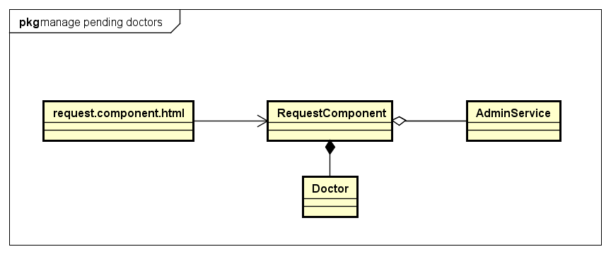

1. request.component.html

Reference to UI design

b. RequestComponent

|  |  |  |  |
| --- | --- | --- | --- |
| **Attribute** | | | |
| No. | Name | Type | Description |
| 1 | currentPage | number | Keep current page is been viewing |
| 2 | totalPages | number | Store total number of pages |
| 3 | doctors | Array<Doctor> | Store list of pending doctors |
| 4 | statusStat | StatusStatistic | Store number of pending doctors |
| 5 | tableDataLoading | boolean | Indicate loading data |
| 6 | searchForm | FormGroup | Instance of FormGroup for search doctor |

|  |  |  |  |  |
| --- | --- | --- | --- | --- |
| **Method** | | | | |
| No. | Name | Params | Return type | Description |
| 1 | searchRecords | Data: any, valid: boolean | void | Sign user out |
| 2 | changeDoctorStatus | doctor: Doctor, status: number | void | Change doctor status |
| 3 | openChangeStatus | Id: string | void | Open status options |
| 4 | trackByID | index: number, item: Doctor | void | Track doctor list by ID |

1. AdminService

|  |  |  |  |
| --- | --- | --- | --- |
| **Attribute** | | | |
| No. | Name | Type | Description |

|  |  |  |  |  |
| --- | --- | --- | --- | --- |
| **Method** | | | | |
| No. | Name | Params | Return type | Description |
| 1 | filterDoctors | account: Account,  name: string,  email: string,  status: number,  pageNo: number,  records?: number | Observable | Send request filter doctors with specific condition. |
| 2 | getDoctor | account: Account, id: string | Observable | Send request get doctor details |

1. Doctor

|  |  |  |  |
| --- | --- | --- | --- |
| **Attribute** | | | |
| No. | Name | Type | Description |
|  | Id | string | Identify for doctor |
|  | firstName | string | First name of doctor |
|  | lastName | string | Last name of doctor |
|  | fullname | string | Full name of doctor |
|  | email | string | Email of doctor |
|  | password | string | Password of doctor |
|  | dob | string | Day of birth |
|  | sex | number | Sex of doctor |
|  | phone | string | Phone of doctor |
|  | role | number | Role of doctor in system |
|  | status | number | Status of doctor’s account |
|  | address | string | Address of doctor |
|  | photo | string | Photo of doctor |
|  | created | string | Time at doctor account created |
|  | lastModified | string | Last time doctor account is modified |
|  | rank | number | Rank of doctor |
|  | specialty | Specialty | Specialty of doctor |
|  | place | Place | Place where doctor work |
|  | noOfVoters | Number | Number of patient who commented |
|  | attachment | string | Attachment of doctor |

|  |  |  |  |  |
| --- | --- | --- | --- | --- |
| **Method** | | | | |
| No. | Name | Params | Return type | Description |

1. Manage a pending doctor

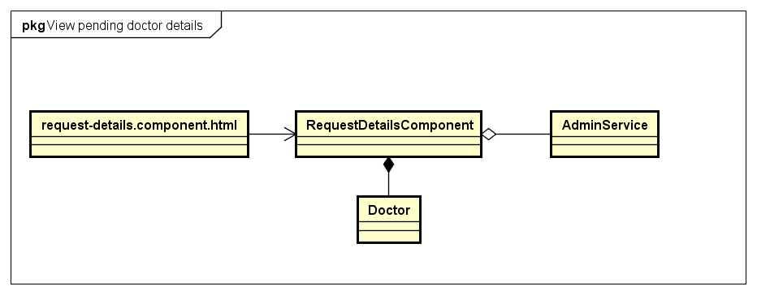

1. Request-details.component.html

Reference to UI design

1. RequestDetailsComponent

|  |  |  |  |
| --- | --- | --- | --- |
| **Attribute** | | | |
| No. | Name | Type | Description |
| 1 | doctor | Doctor | Store doctor details data |
| 2 | userDataLoading | boolean | Indicate data is loading |
| 3 | updatingStatus | boolean | Indicate doctor’s status is updating |

|  |  |  |  |  |
| --- | --- | --- | --- | --- |
| **Method** | | | | |
| No. | Name | Params | Return type | Description |
| 1 | getDoctorProfile | Id: string | void | Get doctor details |
| 2 | changeDoctorStatus | status: number | void | Sign user out |
| 3 | openChangeStatus | Id: string | void | Open status options |

1. AdminService

|  |  |  |  |
| --- | --- | --- | --- |
| **Attribute** | | | |
| No. | Name | Type | Description |

|  |  |  |  |  |
| --- | --- | --- | --- | --- |
| **Method** | | | | |
| No. | Name | Params | Return type | Description |
| 1 | getDoctor | account: Account, id: string | Observable | Send request get doctor details |

1. Doctor

|  |  |  |  |
| --- | --- | --- | --- |
| **Attribute** | | | |
| No. | Name | Type | Description |
|  | Id | string | Identify for patient |
|  | firstName | string | First name of doctor |
|  | lastName | string | Last name of doctor |
|  | fullname | string | Full name of doctor |
|  | email | string | Email of doctor |
|  | password | string | Password of doctor |
|  | dob | string | Day of birth |
|  | sex | number | Sex of doctor |
|  | phone | string | Phone of doctor |
|  | role | number | Role of doctor in system |
|  | status | number | Status of doctor’s account |
|  | address | string | Address of doctor |
|  | photo | string | Photo of doctor |
|  | created | string | Time at doctor account created |
|  | lastModified | string | Last time doctor account is modified |
|  | rank | number | Rank of doctor |
|  | specialty | Specialty | Specialty of doctor |
|  | place | Place | Place where doctor work |
|  | noOfVoters | Number | Number of patient who commented |
|  | attachment | string | Attachment of doctor |

|  |  |  |  |  |
| --- | --- | --- | --- | --- |
| **Method** | | | | |
| No. | Name | Params | Return type | Description |

1. Manage patient list

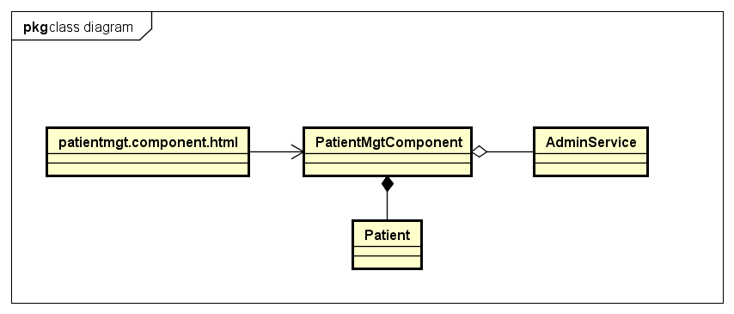

1. Patientmgt.component.html

Reference to UI design

1. PatientMgtComponent

|  |  |  |  |
| --- | --- | --- | --- |
| **Attribute** | | | |
| No. | Name | Type | Description |
| 1 | currentPage | number | Keep current page is been viewing |
| 2 | totalPages | number | Store total number of pages |
| 3 | patients | Patient | Store list of patients |
| 4 | chosenPatient | StatusStatistic | Store current editing patient |
| 5 | statusStat | boolean | Store number of patient with each status |
| 6 | tableDataLoading | boolean | Indicate loading patients data |
| 7 | statsDataLoading | boolean | Indicate loading stats data |
| 8 | searchingPatient | boolean | Indicate searching patients data |
| 9 | searchForm | FormGroup | Instance of FormGroup for searching |

|  |  |  |  |  |
| --- | --- | --- | --- | --- |
| **Method** | | | | |
| No. | Name | Params | Return type | Description |
| 1 | searchRecords | data: any,  valid: boolean | void | Search patient with input data |
| 2 | getAllPatient |  | void | Get all patients data |
| 3 | changePatientStatus | patient: Patient | void | Change patient status |
| 4 | trackByID | index: number, item: Doctor | void | Track patient list by ID |

1. AdminService

|  |  |  |  |
| --- | --- | --- | --- |
| **Attribute** | | | |
| No. | Name | Type | Description |

|  |  |  |  |  |
| --- | --- | --- | --- | --- |
| **Method** | | | | |
| No. | Name | Params | Return type | Description |
| 1 | getPatient | account: Account, id: string | Observable | Send quest to get patient details |
| 2 | filterPatients | account: Account,  name: string,  email: string,  status: AccountStatus, pageNo: number,  records?: number | Observable | Send request filter patients with specific condition. |

1. Patient

|  |  |  |  |
| --- | --- | --- | --- |
| **Attribute** | | | |
| No. | Name | Type | Description |
|  | Id | string | Identify for patient |
|  | firstName | string | First name of patient |
|  | lastName | string | Last name of patient |
|  | fullname | string | Full name of patient |
|  | email | string | Email of patient |
|  | password | string | Password of patient |
|  | dob | string | Day of birth |
|  | sex | number | Sex of patient |
|  | phone | string | Phone of patient |
|  | role | number | Role of patient in system |
|  | status | number | Status of patient’s account |
|  | address | string | Address of patient |
|  | photo | string | Photo of patient |
|  | created | string | Time at patient account is created |
|  | lastModified | string | Last time patient account is modified |
|  | weight | number | weight of patient |
|  | height | number | height of patient |

|  |  |  |  |  |
| --- | --- | --- | --- | --- |
| **Method** | | | | |
| No. | Name | Params | Return type | Description |

7 Manage patient details

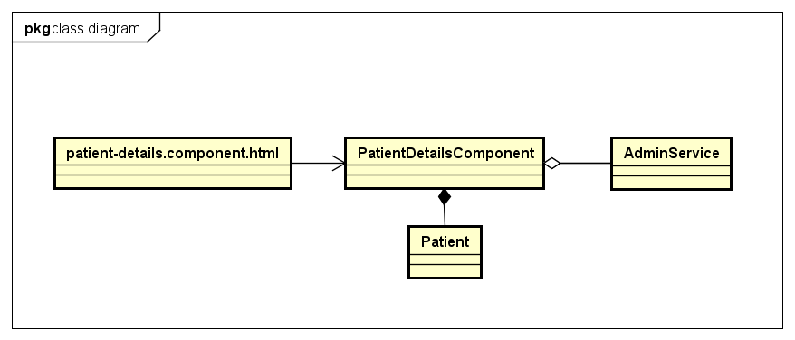

1. Patient-details.component

Reference to UI design

1. PatientMgtComponent

|  |  |  |  |
| --- | --- | --- | --- |
| **Attribute** | | | |
| No. | Name | Type | Description |
| 1 | patient | Patient | Store patient details data |
| 2 | profileLoader | boolean | Indicate data is loading |
| 3 | updatingStatus | boolean | Indicate doctor’s status is updating |

|  |  |  |  |  |
| --- | --- | --- | --- | --- |
| **Method** | | | | |
| No. | Name | Params | Return type | Description |
| 1 | getPatientProfile | Id: string | void | Get patient details |
| 2 | changePatientStatus |  | void | Sign user out |

1. AdminService

|  |  |  |  |
| --- | --- | --- | --- |
| **Attribute** | | | |
| No. | Name | Type | Description |

|  |  |  |  |  |
| --- | --- | --- | --- | --- |
| **Method** | | | | |
| No. | Name | Params | Return type | Description |
| 1 | getPatient | account: Account, id: string | Observable | Send quest to get patient details |

1. Patient

|  |  |  |  |
| --- | --- | --- | --- |
| **Attribute** | | | |
| No. | Name | Type | Description |
|  | Id | string | Identify for doctor |
|  | firstName | string | First name of patient |
|  | lastName | string | Last name of patient |
|  | fullname | string | Full name of patient |
|  | email | string | Email of patient |
|  | password | string | Password of patient |
|  | dob | string | Day of birth |
|  | sex | number | Sex of patient |
|  | phone | string | Phone of patient |
|  | role | number | Role of patient in system |
|  | status | number | Status of patient’s account |
|  | address | string | Address of patient |
|  | photo | string | Photo of patient |
|  | created | string | Time at patient account is created |
|  | lastModified | string | Last time patient account is modified |
|  | weight | number | weight of patient |
|  | height | number | height of patient |

|  |  |  |  |  |
| --- | --- | --- | --- | --- |
| **Method** | | | | |
| No. | Name | Params | Return type | Description |

1. Manage doctor list

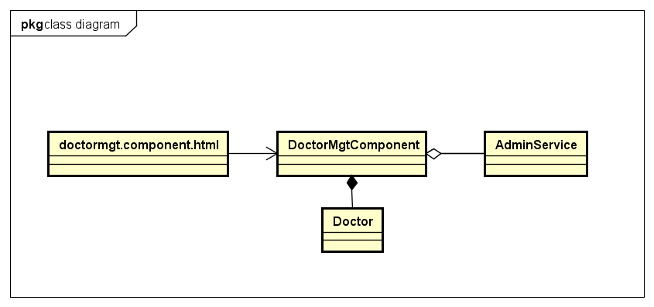

1. Doctormgt.component.html

Reference to UI design

1. DoctorMgtComponent

|  |  |  |  |
| --- | --- | --- | --- |
| **Attribute** | | | |
| No. | Name | Type | Description |
| 1 | currentPage | number | Keep current page is been viewing |
| 2 | totalPages | number | Store total number of pages |
| 3 | doctors | Array<Doctor> | Store list of doctors |
| 4 | statusStat | StatusStatistic | Store number of doctors with each status |
| 5 | tableDataLoading | boolean | Indicate loading doctors data |

|  |  |  |  |  |
| --- | --- | --- | --- | --- |
| **Method** | | | | |
| No. | Name | Params | Return type | Description |
| 1 | searchRecords | data: any,  valid: boolean | void | Search doctor with input data |
| 2 | changeDoctorStatus | doctor: Doctor | void | Change doctor status |
| 3 | trackByID | index: number, item: Doctor | void | Track doctor list by ID |

1. AdminService

|  |  |  |  |
| --- | --- | --- | --- |
| **Attribute** | | | |
| No. | Name | Type | Description |

|  |  |  |  |  |
| --- | --- | --- | --- | --- |
| **Method** | | | | |
| No. | Name | Params | Return type | Description |
| 1 | filterDoctors | account: Account,  name: string,  email: string,  status: number,  pageNo: number,  records?: number | Observable | Send request filter doctors with specific condition. |
| 2 | getDoctor | account: Account, id: string | Observable | Send request get doctor details |

1. Doctor

|  |  |  |  |
| --- | --- | --- | --- |
| **Attribute** | | | |
| No. | Name | Type | Description |
|  | Id | string | Identify for doctor |
|  | firstName | string | First name of doctor |
|  | lastName | string | Last name of doctor |
|  | fullname | string | Full name of doctor |
|  | email | string | Email of doctor |
|  | password | string | Password of doctor |
|  | dob | string | Day of birth |
|  | sex | number | Sex of doctor |
|  | phone | string | Phone of doctor |
|  | role | number | Role of doctor in system |
|  | status | number | Status of doctor’s account |
|  | address | string | Address of doctor |
|  | photo | string | Photo of doctor |
|  | created | string | Time at doctor account created |
|  | lastModified | string | Last time doctor account is modified |
|  | rank | number | Rank of doctor |
|  | specialty | Specialty | Specialty of doctor |
|  | place | Place | Place where doctor work |
|  | noOfVoters | Number | Number of patient who commented |
|  | attachment | string | Attachment of doctor |

|  |  |  |  |  |
| --- | --- | --- | --- | --- |
| **Method** | | | | |
| No. | Name | Params | Return type | Description |

9 Manage doctor details

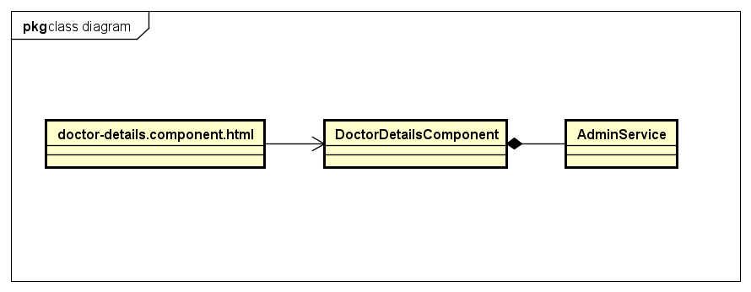

1. Doctor-details.component.html

Reference to UI design

1. DoctorDetailsComponent

|  |  |  |  |
| --- | --- | --- | --- |
| **Attribute** | | | |
| No. | Name | Type | Description |
| 3 | doctor | Doctor | Store doctor details data |
| 4 | profileLoader | boolean | Indicate data is loading |
| 5 | updatingStatus | boolean | Indicate doctor’s status is updating |

|  |  |  |  |  |
| --- | --- | --- | --- | --- |
| **Method** | | | | |
| No. | Name | Params | Return type | Description |
| 1 | changeDoctorStatus | Status: number | void | Change doctor status |
| 2 | openImageViewer | base64: string | void | Open image viewer |
| 3 | closeImageViewer |  | void | Close image viewer |

1. AdminService

|  |  |  |  |
| --- | --- | --- | --- |
| **Attribute** | | | |
| No. | Name | Type | Description |

|  |  |  |  |  |
| --- | --- | --- | --- | --- |
| **Method** | | | | |
| No. | Name | Params | Return type | Description |
| 1 | getDoctor | account: Account, id: string | Observable | Send request get doctor details |

1. Doctor

|  |  |  |  |
| --- | --- | --- | --- |
| **Attribute** | | | |
| No. | Name | Type | Description |
|  | Id | string | Identify for doctor |
|  | firstName | string | First name of doctor |
|  | lastName | string | Last name of doctor |
|  | fullname | string | Full name of doctor |
|  | email | string | Email of doctor |
|  | password | string | Password of doctor |
|  | dob | string | Day of birth |
|  | sex | number | Sex of doctor |
|  | phone | string | Phone of doctor |
|  | role | number | Role of doctor in system |
|  | status | number | Status of doctor’s account |
|  | address | string | Address of doctor |
|  | photo | string | Photo of doctor |
|  | created | string | Time at doctor account created |
|  | lastModified | string | Last time doctor account is modified |
|  | rank | number | Rank of doctor |
|  | specialty | Specialty | Specialty of doctor |
|  | place | Place | Place where doctor work |
|  | noOfVoters | Number | Number of patient who commented |
|  | attachment | string | Attachment of doctor |

|  |  |  |  |  |
| --- | --- | --- | --- | --- |
| **Method** | | | | |
| No. | Name | Params | Return type | Description |

10. Place

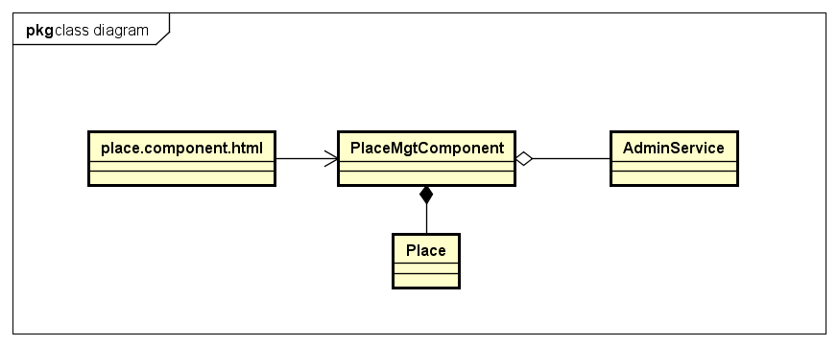

1. Place.componet.html

Reference to UI design

1. PlaceMGtComponent

|  |  |  |  |
| --- | --- | --- | --- |
| **Attribute** | | | |
| No. | Name | Type | Description |
| 3 | doctor | Doctor | Store doctor details data |
| 4 | profileLoader | boolean | Indicate data is loading |
| 5 | updatingStatus | boolean | Indicate doctor’s status is updating |

|  |  |  |  |  |
| --- | --- | --- | --- | --- |
| **Method** | | | | |
| No. | Name | Params | Return type | Description |
| 1 | changeDoctorStatus | Status: number | void | Change doctor status |
| 2 | openImageViewer | base64: string | void | Open image viewer |
| 3 | closeImageViewer |  | void | Close image viewer |

1. AdminService

|  |  |  |  |
| --- | --- | --- | --- |
| **Attribute** | | | |
| No. | Name | Type | Description |

|  |  |  |  |  |
| --- | --- | --- | --- | --- |
| **Method** | | | | |
| No. | Name | Params | Return type | Description |
| 1 | getDoctor | account: Account, id: string | Observable | Send request get doctor details |

1. Place

|  |  |  |  |
| --- | --- | --- | --- |
| **Attribute** | | | |
| No. | Name | Type | Description |
| 1 | id | string | Identify of place |
| 2 | city | string | City name |
| 3 | country | string | Country name |

|  |  |  |  |  |
| --- | --- | --- | --- | --- |
| **Method** | | | | |
| No. | Name | Params | Return type | Description |